**ASSIGNMENT 2 FRONT SHEET**

|  |  |  |  |
| --- | --- | --- | --- |
| **Qualification** | **BTEC Level 5 HND Diploma in Computing** | | |
| **Unit number and title** | Unit 16: Cloud Computing | | |
| **Submission date** |  | **Date Received 1st submission** |  |
| **Re-submission Date** |  | **Date Received 2nd submission** |  |
| **Student Name** | Nguyen Gia Bach | **Student ID** | Gch220163 |
| **Class** | GCH1102 | **Assessor name** | Nguyen Dinh Tran Long |
| **Student declaration**  I certify that the assignment submission is entirely my own work and I fully understand the consequences of plagiarism. I understand that making a false declaration is a form of malpractice. | | | |
|  |  | **Student’s signature** |  |

**Grading grid**

|  |  |  |  |  |  |  |  |
| --- | --- | --- | --- | --- | --- | --- | --- |
| P5 | P6 | P7 | P8 | M3 | M4 | D2 | D3 |
|  |  |  |  |  |  |  |  |

|  |  |  |
| --- | --- | --- |
| **❒ Summative Feedback: ❒ Resubmission Feedback:** | | |
| **Grade:** | **Assessor Signature:** | **Date:** |
| **Internal Verifier’s Comments:** | | |
| **Signature & Date:** | | |

Table of Contents

I. Introduction: 4

II. Design: 4

1. Use case diagram: 4

2. Website screen shoot: 5

# Introduction:

In the previous paper, we discussed some key concepts of cloud computing. This essay will illustrate how to create a web application in the cloud using the approach offered in the previous report. The web application will be built with NodeJS and will use MongoDB as its database. The web will be deploy on internet with Render.

# Design:

## Use case diagram:

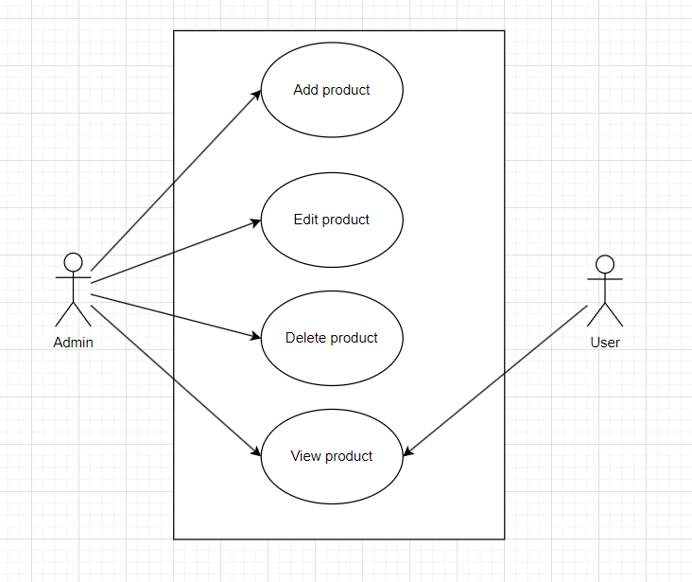

Figure 1: Use case diagram.

* Web application have several functions:
* Add/Update/Delete/View product.

## Website screen shoot:

### Homepage/Index page: